W300D-How to configure DDNS function?
Product line: ADSL Question category: function configuration
Q：Why we need to configure the DDNS?
A：When we use a numeric IP address allocated by Internet Service Provider (ISP) to connect to Internet, the address may either be stable ("static"), or may change from one session on the Internet to the next ("dynamic"). However, a numeric address is inconvenient to remember; an address which changes unpredictably makes connection impossible. The DDNS provider allocates a static hostname to the user, thus, uninterrupted access to devices and services whose numeric IP address may change is maintained.

I. Physical connection:
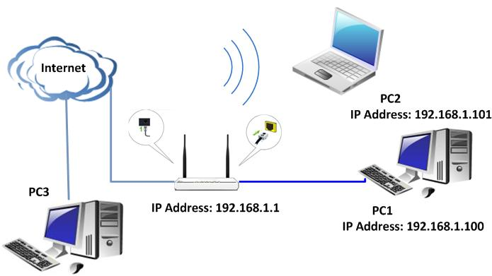
II. Login to the management page of the router:
1. Open a web browser (IE, Firefox, Safari, etc.) and find the address bar, leaving it blank before typing in 192.168.1.1, and then press enter.
(Care: The address bar is in the most top of the web page after opening web browser).
2. Click on Advanced Settings in the following page.
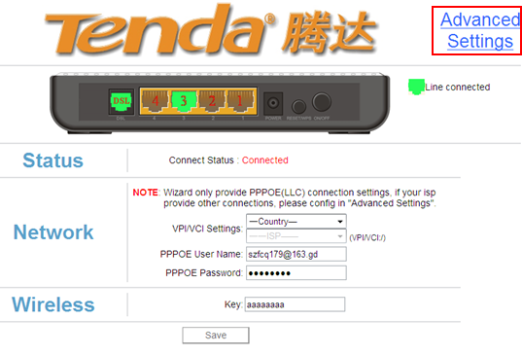
3. You will see the following page.
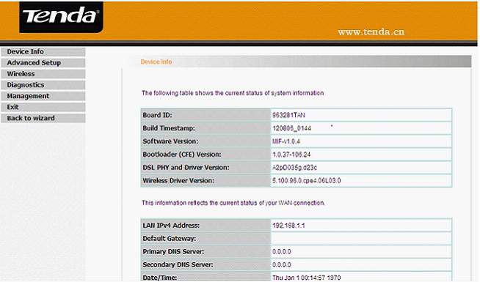
4. Click Advanced Setup->DNS->Dynamic DNS on the left side.
You will see the following page.
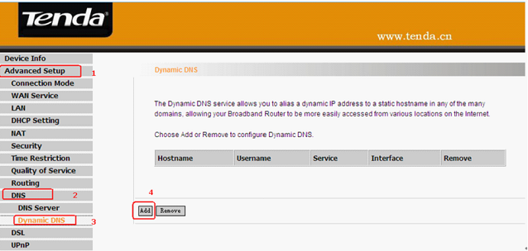
5. Configuring the Dynamic DNS.
(1) Select one Service Provider from the drop-down menu.
(2) Set a domain name for your device in the blank of Hostname.
(3) Enter the user name the same as the registration name.
(4) Enter the password you set when do the DDNS registration.
(5) Click on Save/Apply to finish.
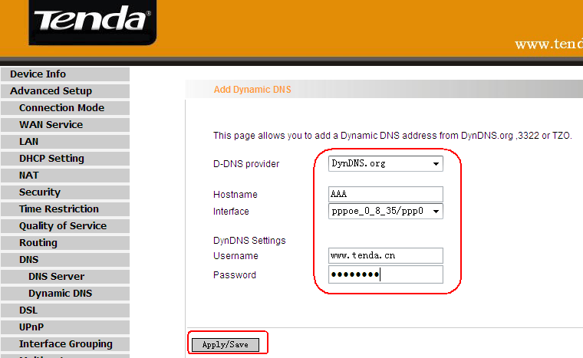
After the settings, you can access hosting website, FTP server with domain name instead of WAN IP address.
For example: ftp://AAA not ftp://WAN IP 2.2.2.2

